  Hammad Ahmed Awan

CMS-ID: 021-19-0018

BSCS-VII, Sec ‘A’

Submitted To: Sir Nisar Ahmed Siddique

Mobile Application Development Lab no.2&3

**Task 1**

**Code:**

**package com.example.lab2activities  
  
import android.content.Intent  
import androidx.appcompat.app.AppCompatActivity  
import android.os.Bundle  
import android.os.PersistableBundle  
import android.util.Log  
import android.view.ActionMode  
import android.view.View  
import android.widget.Button  
  
class MainActivity : AppCompatActivity() {  
 override fun onCreate(savedInstanceState: Bundle?) {  
 super.onCreate(savedInstanceState)  
 setContentView(R.layout.*activity_main*)  
  
 Log.d("create","I am create")  
  
 val btn = findViewById<Button>(R.id.*button3*)  
 btn.setOnClickListener( View.OnClickListener{  
  
 val intent : Intent = Intent(this, MainActivity2::class.*java*)  
 startActivity(intent) })  
  
 }  
  
 override fun onStart() {  
 super.onStart()  
 Log.d("Start","I am Start")  
 }  
 override fun onResume() {  
 super.onResume()  
 Log.d("Resume","I am Resume")  
 }  
 override fun onPause() {  
 super.onPause()  
 Log.d("Pause","I am Pause")  
 }  
 override fun onStop() {  
 super.onStop()  
 Log.d("Stop","I am Stop")  
 }  
 override fun onRestart() {  
 super.onRestart()  
 Log.d("Restart","I am Restart")  
 }  
 override fun onDestroy() {  
 super.onDestroy()  
 Log.d("Destroy","I am Destroy")  
 }  
}**

**Output:**

**What callback is call when an app is first launched?**

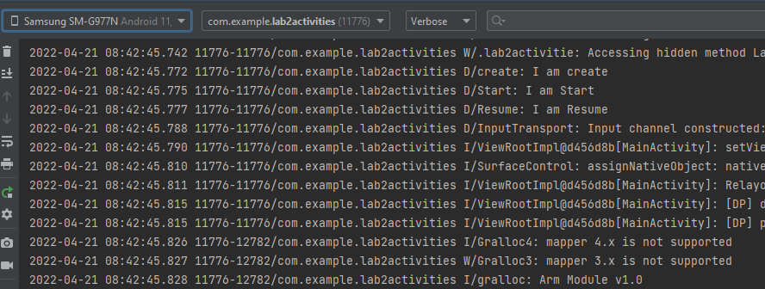

**It calls onCreate, OnStart and OnResume**

**What callbacks occurs when HOME is Pressed?**

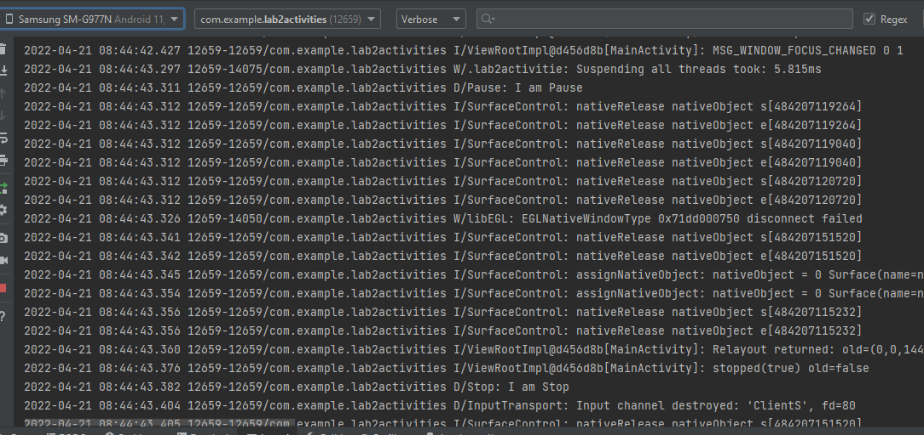

**It calls OnPause and OnStop**

**What callbacks occurs when an app is restarted from the launched?**

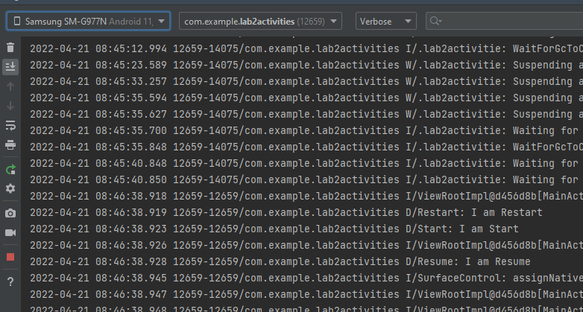

**It calls OnRestart, OnStart and OnResume**

**What callbacks occurs when the device is rotated?**

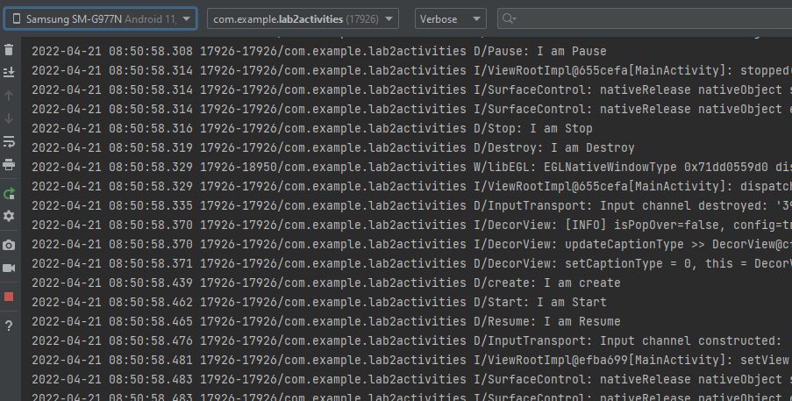

**It calls OnPause, OnStop, OnDestroy, OnCraete, Onstart and OnResume**

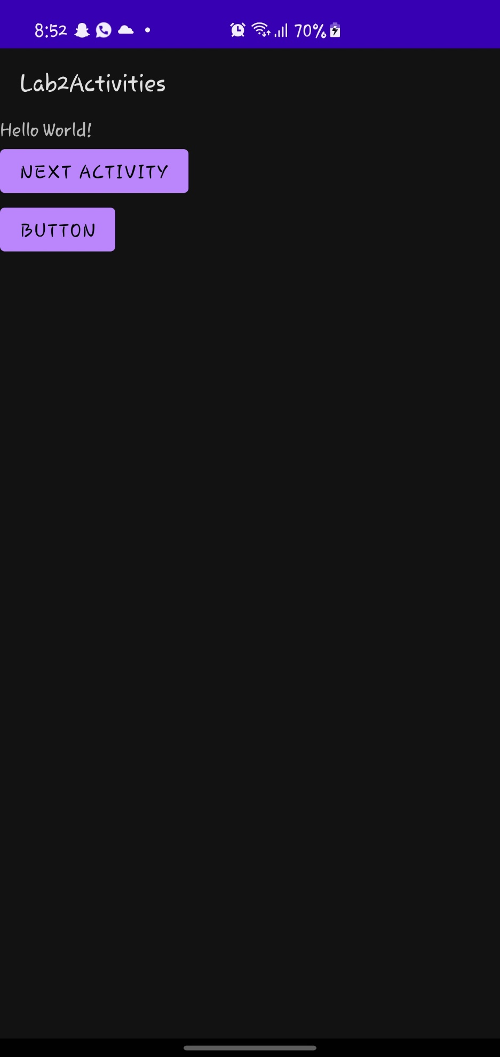

**Task2**

**Code:**

**package com.example.lab2activities**

**import android.content.Intent**

**import androidx.appcompat.app.AppCompatActivity**

**import android.os.Bundle**

**import android.view.View**

**import android.widget.Button**

**import android.widget.ImageView**

**import android.widget.TextView**

**class MainActivity2 : AppCompatActivity() {**

**override fun onCreate(savedInstanceState: Bundle?) {**

**super.onCreate(savedInstanceState)**

**setContentView(R.layout.*activity_main2*)**

**var label = findViewById<TextView>(R.id.*textView2*)**

**var btn = findViewById<Button>(R.id.*button*)**

**var btn2 = findViewById<Button>(R.id.*button2*)**

**var pic = findViewById<ImageView>(R.id.*imageView*)**

**btn.setOnClickListener {**

**label.setText("I Am Full")**

**btn.setText("DONE...")**

**pic.setImageResource(R.drawable.*happy*)**

**}**

**btn2.setOnClickListener(View.OnClickListener {**

**val intent : Intent = Intent(this,MainActivity3::class.*java*)**

**startActivity(intent)**

**})**

**}**

**}**

**Output:**

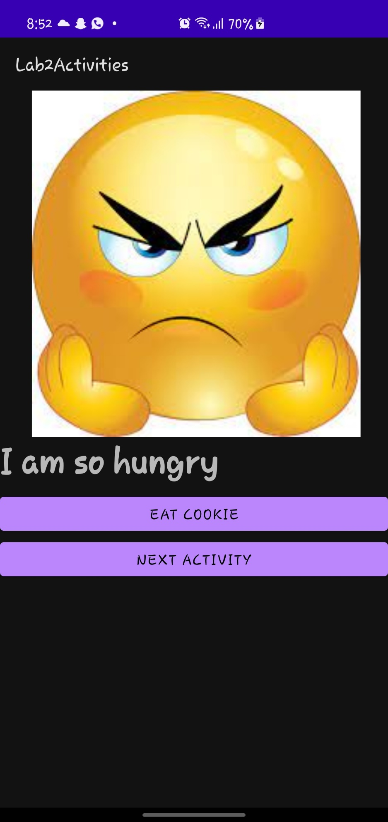

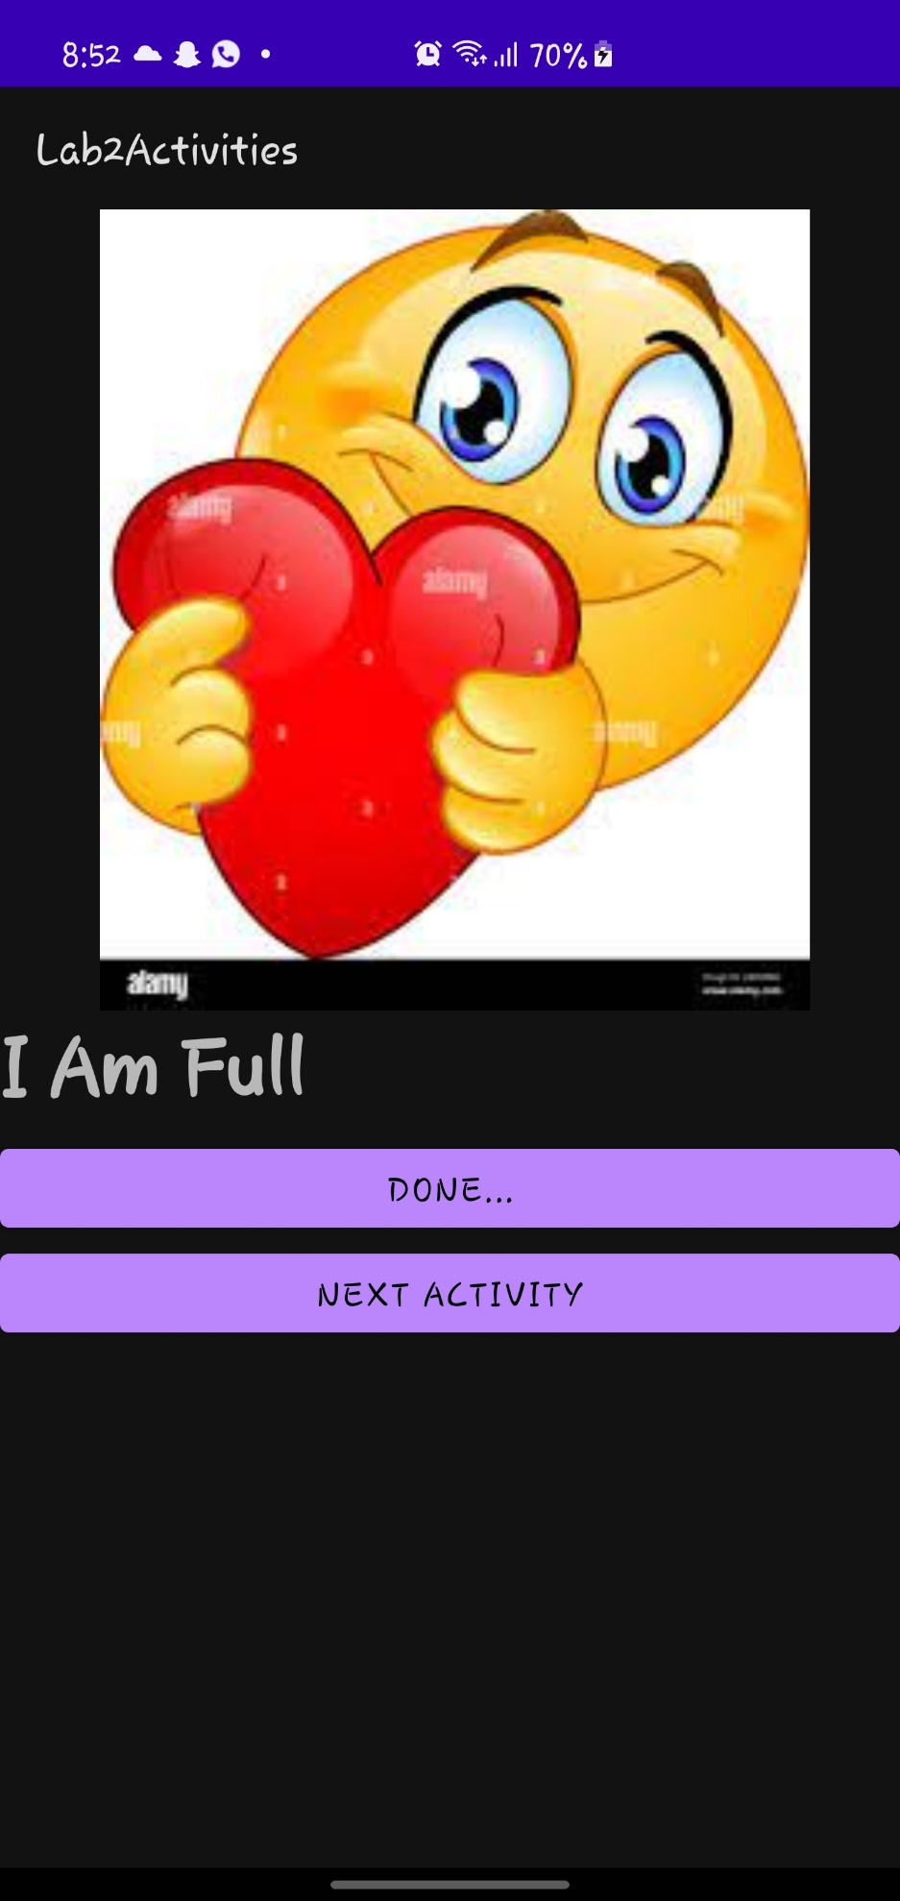

**Task3:**

**Code:**

**package com.example.lab2activities**

**import androidx.appcompat.app.AppCompatActivity**

**import android.os.Bundle**

**import android.widget.Button**

**import android.widget.CheckBox**

**import android.widget.TextView**

**import android.content.Intent as Intent1**

**class MainActivity3 : AppCompatActivity() {**

**override fun onCreate(savedInstanceState: Bundle?) {**

**super.onCreate(savedInstanceState)**

**setContentView(R.layout.*activity_main3*)**

**val cb1 = findViewById<CheckBox>(R.id.*checkBox3*)**

**val cb2 = findViewById<CheckBox>(R.id.*checkBox4*)**

**val btn1 = findViewById<Button>(R.id.*button6*)**

**val btn2 = findViewById<Button>(R.id.*button7*)**

**val btn3 = findViewById<Button>(R.id.*button8*)**

**val tf1 = findViewById<TextView>(R.id.*textView4*)**

**val tf2 = findViewById<TextView>(R.id.*editTextTextMultiLine*)**

**var price: Double = 0.0**

**val btn = findViewById<Button>(R.id.*button5*)**

**btn.setOnClickListener{**

**val intent : Intent1 = Intent1(this,MainActivity4::class.*java*)**

**startActivity(intent)**

**}**

**btn1.setOnClickListener()**

**{**

**tf1.*text* = (Integer.parseInt(tf1.*text*.toString()) - 1).toString()**

**}**

**btn2.setOnClickListener()**

**{**

**tf1.*text* = (Integer.parseInt(tf1.*text*.toString()) + 1).toString()**

**}**

**btn3.setOnClickListener()**

**{**

**price = 0.0**

**if(cb1.*isChecked*)**

**{**

**tf2.*text* = "Add Wipped Cream? yes\n"**

**price++**

**}**

**else**

**{**

**tf2.*text* = "Add Wipped Cream? no\n"**

**}**

**if(cb2.*isChecked*)**

**{**

**tf2.*text* = tf2.*text*.toString() + "Add Chocolate? yes\n"**

**price++**

**}**

**else**

**{**

**tf2.*text* = tf2.*text*.toString() + "Add Chocolate? no\n"**

**}**

**price = price +(4 * Integer.parseInt(tf1.*text*.toString()))**

**tf2.*text* = tf2.*text*.toString() + "Quantity : " + tf1.*text*.toString() +"\n\n" + "Price : $"+ price + "\nThankYou!"**

**}**

**}**

**}**

**Output:**

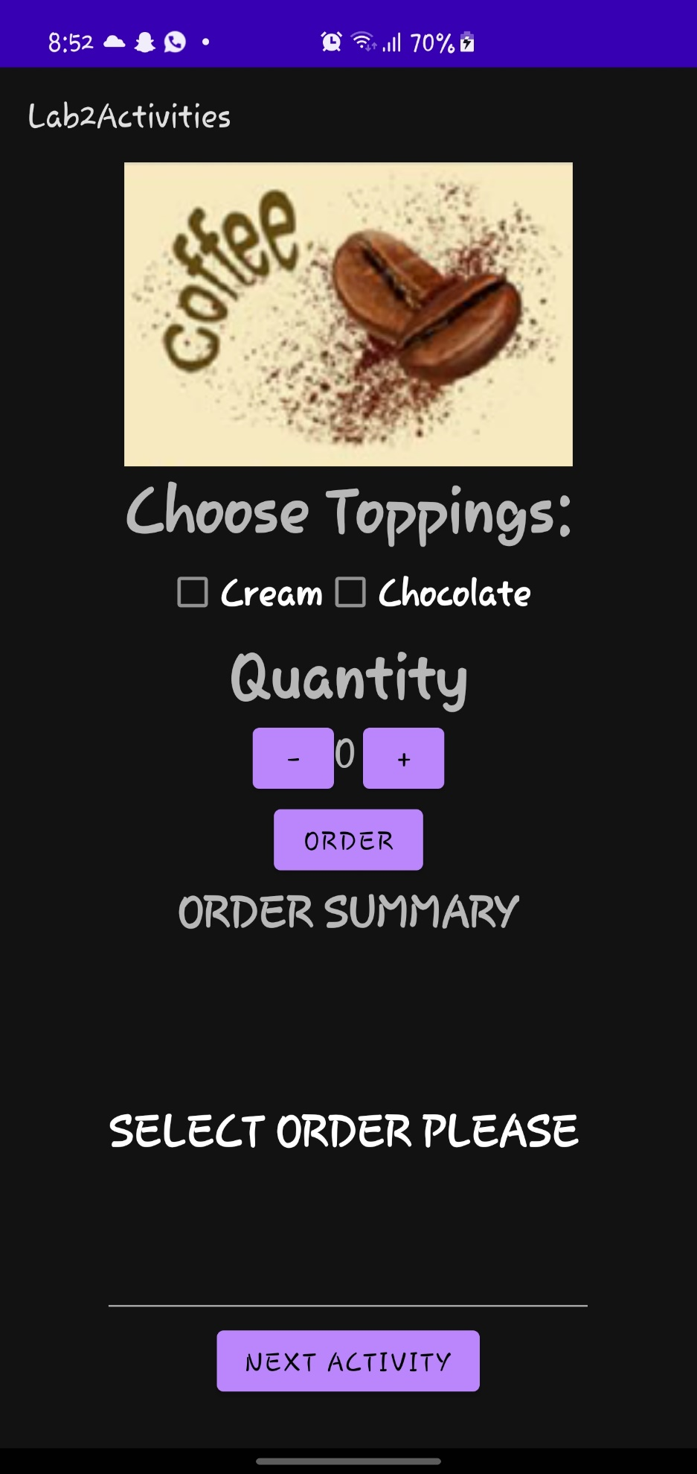

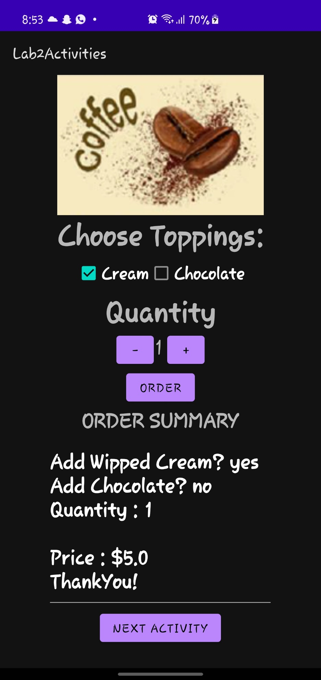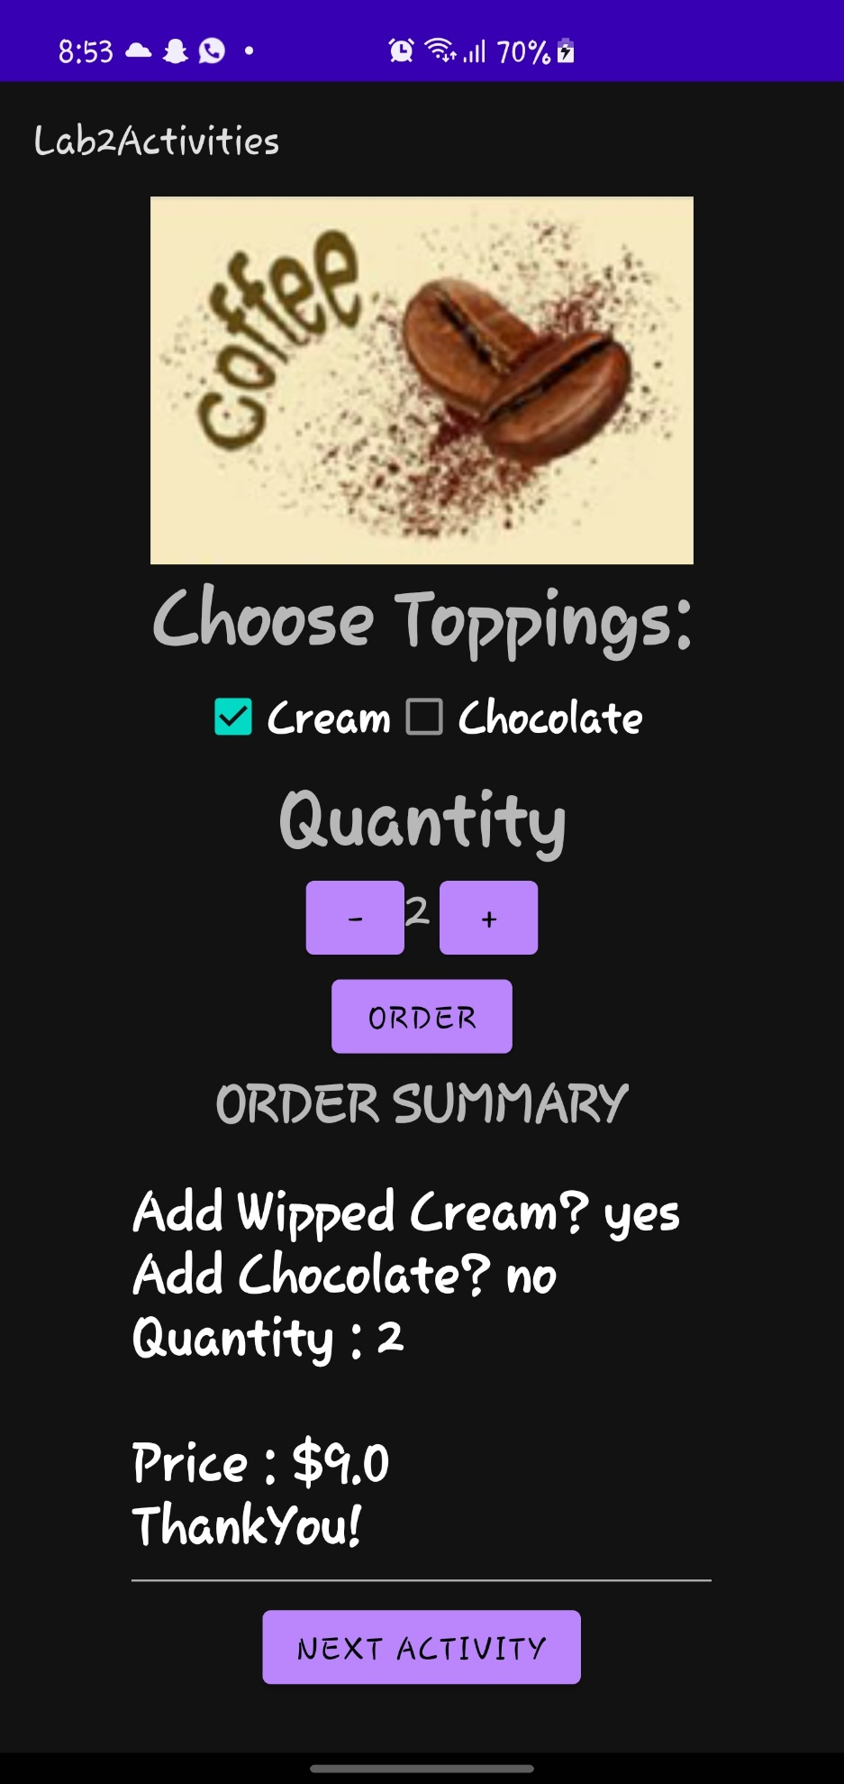

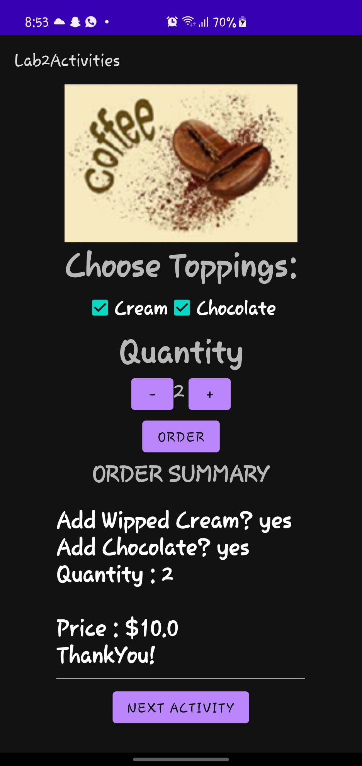

**Task4**

**Code:**

**package com.example.lab2activities**

**import androidx.appcompat.app.AppCompatActivity**

**import android.os.Bundle**

**import android.widget.Button**

**import android.widget.TextView**

**class MainActivity4 : AppCompatActivity() {**

**override fun onCreate(savedInstanceState: Bundle?) {**

**super.onCreate(savedInstanceState)**

**setContentView(R.layout.*activity_main4*)**

**val btnClear = findViewById<Button>(R.id.*Clear*)**

**val btnMode = findViewById<Button>(R.id.*mode*)**

**val btnDivide = findViewById<Button>(R.id.*divide*)**

**val btnAdd = findViewById<Button>(R.id.*plus*)**

**val btn1Multi = findViewById<Button>(R.id.*multiply*)**

**val btnMinus = findViewById<Button>(R.id.*minus*)**

**val btnEqual = findViewById<Button>(R.id.*equal*)**

**val btn1 = findViewById<Button>(R.id.*btn1*)**

**val btn2 = findViewById<Button>(R.id.*btn2*)**

**val btn3 = findViewById<Button>(R.id.*btn3*)**

**val btn4 = findViewById<Button>(R.id.*btn4*)**

**val btn5 = findViewById<Button>(R.id.*btn5*)**

**val btn6 = findViewById<Button>(R.id.*btn6*)**

**val btn7 = findViewById<Button>(R.id.*btn7*)**

**val btn8 = findViewById<Button>(R.id.*btn8*)**

**val btn9 = findViewById<Button>(R.id.*btn9*)**

**val btn0 = findViewById<Button>(R.id.*btn0*)**

**val tf = findViewById<TextView>(R.id.*textArea*)**

**var operand1 : Double = 0.0**

**var operator : Char = '0'**

**var operand2 : Double = 0.0**

**var result : Double = 0.0**

**btn0.setOnClickListener{tf.*text* = tf.*text*.toString() + "0"}**

**btn1.setOnClickListener{tf.*text* = tf.*text*.toString() + "1"}**

**btn2.setOnClickListener{tf.*text* = tf.*text*.toString() + "2"}**

**btn3.setOnClickListener{tf.*text* = tf.*text*.toString() + "3"}**

**btn4.setOnClickListener{tf.*text* = tf.*text*.toString() + "4"}**

**btn5.setOnClickListener{tf.*text* = tf.*text*.toString() + "5"}**

**btn6.setOnClickListener{tf.*text* = tf.*text*.toString() + "6"}**

**btn7.setOnClickListener{tf.*text* = tf.*text*.toString() + "7"}**

**btn8.setOnClickListener{tf.*text* = tf.*text*.toString() + "8"}**

**btn9.setOnClickListener{tf.*text* = tf.*text*.toString() + "9"}**

**btnClear.setOnClickListener{tf.*text* = ""}**

**btnMode.setOnClickListener{**

**operand1= tf.*text*.toString().*toDouble*()**

**tf.*text* =""**

**operator = '%'**

**}**

**btnAdd.setOnClickListener{**

**operand1= tf.*text*.toString().*toDouble*()**

**tf.*text* =""**

**operator = '+'**

**}**

**btnMinus.setOnClickListener{**

**operand1= tf.*text*.toString().*toDouble*()**

**tf.*text* =""**

**operator = '-'**

**}**

**btn1Multi.setOnClickListener{**

**operand1= tf.*text*.toString().*toDouble*()**

**tf.*text* =""**

**operator = '*'**

**}**

**btnDivide.setOnClickListener{**

**operand1= tf.*text*.toString().*toDouble*()**

**tf.*text* =""**

**operator = '/'**

**}**

**btnEqual.setOnClickListener{**

**operand2= tf.*text*.toString().*toDouble*()**

**when(operator)**

**{**

**'+' -> result = operand1 + operand2**

**'-' -> result = operand1 - operand2**

**'*' -> result = operand1 * operand2**

**'/' -> result = operand1 / operand2**

**'%' -> result = operand1 % operand2**

**else -> {result=0.0}**

**}**

**tf.*text* ="" + result**

**}**

**}**

**}**

**Output:**

